UNIT 4-7 ASSIGNMENT 2

Programming AND MOBILE APPS

Oliver Collins-Cope

2022

Contents

Introduction 2

Scope of Project – Design 2

Mobile requirements 2

Device capabilities 3

Input required 3

Output required 3

User needs 3

Pseudocode for Program 3

Software solutions design 5

To resolve 5

Purpose and requirements 6

Features of the software design 6

Choice of language 8

List of predefined programs/code snippets 9

Premade assets 9

Feedback from others 9

Test data 11

Technical constraints 11

Designing a mobile app 11

User requirements 11

A proposed solution 11

Alternative solutions 12

Details of resources used 12

Test and review schedule 12

Mobile constraints 12

Legal and ethical considerations 12

Application Development 13

# Introduction

# Scope of Project – Design

The project is to create a program for temporary traffic lights that can be operated using a mobile device. It is being created due to the roadwork occurring and it will help to allow traffic to flow functionally without halting day to day life. It has been approved by the relevant organisation “Highway-RUTC Road Services” and the project will be completed through numerous different phases which will be elaborated on further, such as planning and implementation phases. The product produced will be a functioning program which will be able to change traffic lights using a mobile, and will follow the predetermined eight set instruction sequence that lasts forty-four seconds. It will be delivered by the 20th of May and is estimated to cost a grand total of £0 through the use of ~~slave~~ student labour.

To be included in the program includes the correct operational sequences for both Set A and Set B of the traffic lights. Furthermore, there will be an option to override the operational sequence in order to set both traffic lights to red in case of an incident/accident. Following this, the user will be able to safely restart the traffic light operational sequence after overriding the program and it will continue to function smoothly. All of this will be achieved through a mobile app that will be developed around the program I will create.

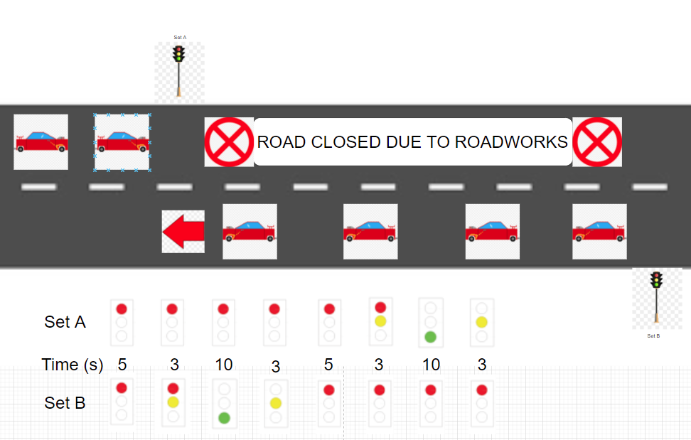

## Mobile requirements

There are four components to consider for the mobile application to consider when designing the mobile application. These are:

* Device capabilities
* Input required
* Output required
* User needs

### Device capabilities

The device capabilities refer to things such as GPS, or an accelerometer. For this situation/program, it is important that the devices that use the app we create have touch screen capabilities in order for the user to interact with the buttons that will be present in the application, whether it is to activate the program or to activate the emergency stop.

### Input required

Similar to the device capabilities that we require for this application and program, “Input required” refers to what input the program will seek from the user, such as voice input, or a timed event. For our program, we will be using a combination of touch screen and timed events.

We will be using touch screen in order to begin the program and activate the emergency stop using the mobile device on the application, and we will be using timed events to ensure that the operational sequences on the traffic lights eight different options runs smoothly and in time to prevent issues arriving from cars colliding.

### Output required

The output required asks the program what the output of the input will be. As mentioned above, this will be the traffic lights working in the order they are established to be working in, going through the eight different sequences, along with the emergency stop option.

This is important as this output component will be what allows the program to operate functionally and dictate the response from what the user inputs.

### User needs

Finally, there are also the user needs to consider, such as whether the user needs accessibility options, or any kind of location services. In this situation, some examples of possible user needs may be a password protected system, so only authorised users are able to affect the traffic lights, and accessibility options in-case the user operating the application might have different disabilities, such as blindness or epilepsy. We can achieve these different user needs by ensuring the program is able to be accessed by third party voice screen readers and applications such as “VoiceOver” by Apple. We can cater to epilepsy users needs by ensuring that the application/program does not contain any potentially triggering content, such as flashing lights.

These are important to consider as making an application as accessible as possible to different users is crucial as a developer in order to allow for as many users as possible to be able to use the application and not be restricted by their disabilities. Furthermore, it is also good practice to ensure that disabled users are able to access and fully use the produced application just the same as abled users.

## Pseudocode for Program

Input Driver Age

If Driver Age is greater than 16

Then they are allowed to drive

Else

They are not allowed to drive

Is there an accident?

Input Yes/No

If Yes

Then Emergency Stop

Else

Continue running traffic lights

Input Touch screen

If button program is pressed

Traffic lights Set A Off/Red (5)

Traffic lights Set B Off/Red (5)

Traffic lights Set A Off/Red (3)

Traffic lights Set B Half/Red&Yellow (3)

Traffic lights Set A Off/Red (10)

Traffic lights Set B On/Green (10)

ETC

Else

Program does not run and traffic lights stay off

Input Age

If Age is greater than 16

Return Yes

Else

Return No

Module Module1

Sub Main()

Dim Age as Integer = Nothing

Console.WriteLine(“What is your age?”)

Age = Console.ReadLine()

If Age >= “16” Then

Console.WriteLine(“You are old enough to drive”)

Else

Console.WriteLine(“You are not old enough to drive”)

End If

Console.ReadLine()

End Sub

End Module

## Software solutions design

There are several things to include when discussing the software design and viable solutions. To begin with, I will discuss different problems that must be resolved before planning out the software and programming.

### To resolve

These include:

* Intended users
* Summary of the program and solutions
* Constraints
* Benefits
* Interactivity
* Complexity

#### Intended users

The intended users of this application and software will be members of the company Highway RUTC Road Services, which are likely to be slightly older people who might not be as technologically literate, and therefore our software should be as simple as possible to minimise chances of confusion.

#### Summary of the program and solutions

The program will include a diagram of the two sets of traffic lights, and these traffic lights will change colour depending on the timing of the predefined operational sequence. Due to the fact that the brief states that the actual timing of the traffic lights will be different, it will be important to include the option to easily be able to change the timing of each step of the correct operational sequence.

One way I will be able to achieve this is through setting up an internal timer with the code, and when the timer reaches a certain value, it will change the colour of the traffic lights and therefore run through the correct operational sequences.

#### Constraints

Some constraints that may be encountered along the way with the development of this program could be that setting up the internal timer and making sure it functions the way it is required will be much harder than initially predicted and therefore there may be bugs or I will have to change the way I decide what time to change the code.

Another constraint I may come across would be I am able to turn this into a mobile application and have it run for the user; However, I believe that I have resolved this issue already through deciding how I am going to make my software, which I will discuss in the section below.

#### Benefits

I will be using the game development software “Unity” in order to make my software application. I believe this is a benefit because it allows for builds in mobile which means I do not have to worry about making my program function on mobile. In addition to this, I will be able to make different menus for the user and present customisable options through the use of “scenes” and “game objects” which interact with each other.

#### Interactivity

The interactivity of my application will be limited to buttons that the user can press in order to achieve the desired results. I am limiting the interactivity of my application in order to reduce confusion and limit user error. This will result in less errors occurring and less bugs developing and therefore the application will continue to work for longer without the need for updates or hotfixes.

#### Complexity

I do not believe that my application will be particularly complex, and I will do all I can to ensure that the UI of my application and the navigation of my application will be simple in order to reduce complexity and confusion.

### Purpose and requirements

In this section I will clearly outline the purpose of my application and the requirements of the user in further detail, while including how I will meet these requirements and my justification for doing in that way.

#### Purpose

The purpose of this software and mobile application will be to create a software solution that can operate a traffic light software system using predetermined operational sequences.

#### Requirements

The requirements of this software solution include following the correct operational sequence, which I will achieve through using a timer, and I will be doing it in this way as it will allow me to keep track of the timing within the code and allow it to be independent. To be able to safely override the operational sequence and restart it in the case of an emergency, which I will achieve by including a button which stops the code from executing and sets the lights to red. Finally, to develop a mobile app for this which can achieve this, which I will do using Unity because it has build options for mobile.

### Features of the software design

The features of the software design will cover:

* Main tasks, inputs, and outputs
* Illustrations
* Algorithms and pseudocode
* Data Structures(?)
* Data Storage(?)
* Control structures
* Data validation
* Error handling and reporting

The requirements of this software solution include following the correct operational

#### Main tasks, inputs, outputs

The main tasks, inputs, and outputs of this program will include:

Main tasks – starting the lights and running the correct operational sequence for them.

Inputs – the user pressing the button on the screen in order to start the traffic lights and emergency stop them.

Output – to output the current setting that the traffic lights are on, and a noise when the emergency stop is played.

#### Illustrations

The layout of my application will look something like this.

Set B

Set A

STOP

START

#### Algorithm and pseudocode

The pseudocode for my application will be this, as I believe this is the best way to do this.

IF BUTTON START PRESSED Then

Start coroutine sequence1

Or I will establish a timer and when that timer reaches past a certain value, it will run a specific function which sets the light to the right colours.

IF BUTTON START PRESSED Then

timerLights += Time.deltatime

IF timerLights > int step1Time Then

Sequence1();

IF timerLights > int step2Time Then

Sequence2();

Ect…

#### Data structure

I will be structuring my data to be easily manipulated by the user in Unity, with fields exposed to the inspector so the user can easily configure the sequence time. In addition to this, I will make as much of my data as I can private and not public, in order to minimise the risk of errors occurring when running my program.

#### Data storage

My data will be stored inside of my program in my scripts written in C#. This will allow my program to run optimally and minimise build size.

#### Control structures

My program will include many control structures as they will be what allows my program to function properly, and I will make sure to include comments on my code in order for people to understand the code.

#### Data validation

I will ensure that the data is valid through the data types used declared in my scripts. For example, the timer will be a float as time has a decimal values, however the specific times at which the lights change, the “step1Time” will be integers, as these will be prespecified seconds.

#### Error handling and reporting

To handle my errors and reporting them, I will include debug.logs in my testing of my program, and if it is necessary, I will throw an error box on the screen when something unexpected happens with my code in order to inform the user that it is not functioning correctly.

### Choice of language

I will be using C# in order to make my program as this is the language used by Unity, and therefore this decision was already made when I made the choice to use Unity as my program. It was based off of C, the low level programming language, and expanded on many of its original and powerful features. Today, C# is a static typing, [strong typing](https://en.wikipedia.org/wiki/Strong_typing), [lexically scoped](https://en.wikipedia.org/wiki/Lexically_scoped), [imperative](https://en.wikipedia.org/wiki/Imperative_programming), [declarative](https://en.wikipedia.org/wiki/Declarative_programming), [functional](https://en.wikipedia.org/wiki/Functional_programming), [generic](https://en.wikipedia.org/wiki/Generic_programming), [object-oriented](https://en.wikipedia.org/wiki/Object-oriented_programming) ([class](https://en.wikipedia.org/wiki/Class_(computer_science))-based), and [component-oriented](https://en.wikipedia.org/wiki/Component-based_software_engineering) programming disciplines.

### List of predefined programs/code snippets

The only pre-defined program to mention will be Unity, as this is the software I will be using to develop my application, and potentially visual studio as I will be using this as my IDE to program in C# for my applications.

### Premade assets

I may use premade traffic light images, however it is very likely that I will use boxes that I change the colour of as this will save space and loading times for the application.

I will also likely use some sort of alarm noise that I will download from somewhere, provided I have permission to use it in my application.

### Feedback from others

Here I will ask for feedback regarding what I have written so far, as well as acting on that and improving my assignment based on what I receive.

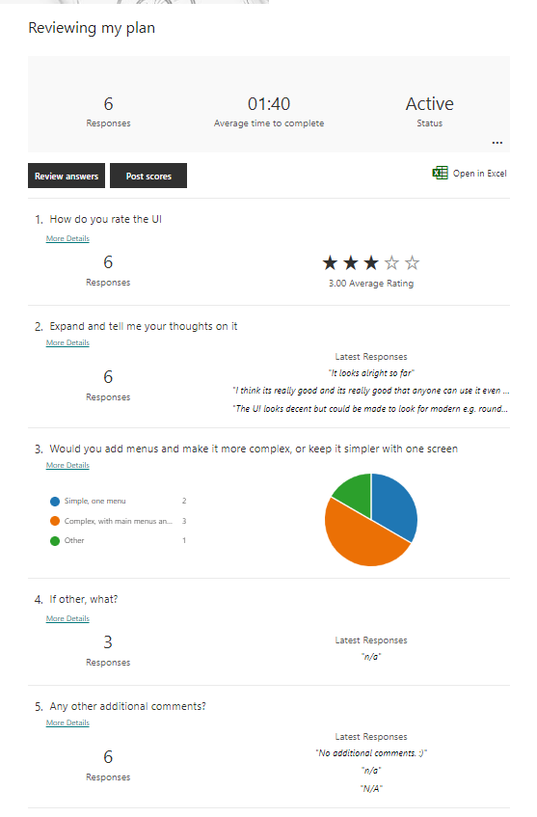

Judging from the reaction to my assignment, I will adjust my plan to include another main menu screen before it loads the screen I depicted above. Furthermore, I will add more modern displays in my final design, such as circles over squares in order to make it look more like actual traffic lights.

### Test data

I will include test data once I have begun developing my program as I do not want to skip important steps such as deciding on my architecture of my program and things such as requirements for my application which are vital to development.

### Technical constraints

Some technical constraints I may encounter could be limitations with getting the application on apple devices.

Another technical constraint I might run into could be limitations with the programming language I am using and the software, however I am not aware of any that I might meet and therefore I believe that I will mostly be free of technical constraints.

## Designing a mobile app

I will briefly cover this section of my assignment, as a significant part of it is covered in the programming aspect with “Software solutions design” above.

### User requirements

As discussed above, the user requires an application which can change the traffic lights by following a specific sequence and therefore changing when required, which can also stop at the press of a button and restart when another is pressed.

### A proposed solution

A majority of this section was covered above; however, I will include it for complete clarity and to ensure everything was covered to the best of my ability.

* Program tasks
* Target platforms
* Screen layouts and navigation
* Algorithm and pseudocode
* Control structures
* Data validation
* Integration of device capabilities

#### Program tasks

My programs tasks will be running the application and the lights in the correct sequence as I had previously mentioned. Furthermore, stopping when a button is pressed and being able to restart without issues.

#### Target platforms

The target platforms for my application will be iOS devices as well as Android devices, however I will include build options for windows so users can test out the application as if it was a mobile emulator before the use it on mobile.

#### Screen layouts and navigation

The screen layout and navigation of my application has been discussed above as well, I will include a main menu which users will load into, and then once they press a button to proceed to the application, I will add the circles for my traffic lights, and my buttons which start and stop the sequence respectively.

#### Algorithms and pseudocode, control structures, data validation

All of these have been discussed above and I will not discuss them here, please see pages 8 and 9 for this.

#### Integration of device capabilities

My application will not include and integration of device capabilities as I do not believe that a traffic light system requires this, and if I added device capabilities then my application will be limited to specific devices that I have added these capabilities for, and I want to ensure that my application can be used universally.

### Alternative solutions

Some other solutions that could be included might be making the app to be developed landscape rather than portrait, however I do not think this is appropriate for my application. Another example of an alternative solution would be to develop my program in something like windows forms, however I am not certain how I would port it to mobile so I believe that the way I have chosen is the best for me.

### Details of resources used

The only resources I will be using (as discussed above) will be the audio of an alarm noise for my emergency stop button in order to help alert the user.

See above for more detail.

### Test and review schedule

As mentioned above, I have no current test and review schedule however once I begin developing my program then I will add my tests as I produce my program.

### Mobile constraints

Some mobile constraints that I may run into could be device limitations with battery and such. Another mobile constraint I might run into is if my mobile device is too outdated, I will not be able to download and run the application, and therefore I have to develop for older devices as well.

Furthermore, the phone may not be able to handle the load my application will put on it. However, considering the program and application size, I have concluded that if this is an issue, then it is the fault of the device being outdated and will not be able to run other applications either.

### Legal and ethical considerations

The legal and ethical considerations for me to consider would be any data gathering that I would like my application to do, which I will not include, and any copyright issues. In order to avoid these copyright issues, I will make sure I have the rights to whatever sound I use for the alarm so I can proceed with peace of mind.  
I may also have to consider any ethical issues like ensuring the application I design is suitable for users with accessibility issues like colour blind issues, and I will resolve this by adding in text for my application that ensures the users understand which lights are turned on and which are off.

# Application Development

## Content preparation and software solutions development

### Software solutions development

This will include:

* The development environment to produce code
* The development and the refinement of my program using C# (the suitable programming language)
* Libraries, standard code, and user generated subroutines for efficacy

#### Development environment

I will be using Visual Studio 2022 Community as my IDE for developing my program, as it is the IDE I am most familiar with, and is the standard Unity IDE, other than monodevelop, however I have no experience with this, and Visual Studio is a reliable IDE.

#### Refinement of my program

In order to further enhance and refine program, linked with user generated subroutines, majority of my code will be made within functions that are aptly named so it is easier to read and understand without having to look at all of my code. I have done my programming in C# as that is the programming language for Unity.

#### Libraries, code, efficiency

As mentioned above, I am making my own subroutines, also known as functions however as they do not return values then some could argue they are not functions, which has all of my code for each of the steps of the sequence, which can each be individually modified without difficulty and without struggling to locate the correct part of the code, as it is named under each function.

I will be using the Unity Libraries that come with Unity in order to do this and the standard code alongside it.

### Content preparation

This will cover:

* Selection and application of appropriate processing and editing for the specific devices
* Optimisation
* Formats
* File formats
* Compression

#### Selection and application of appropriate processing and editing for the specific devices

The goal with my application is to make it run universally across all applications without having the need to modify it for different devices, and therefore I will avoid doing things for specific devices.

#### Optimisation

The only file that the application has which the user might have to load would be the audio file, which is compressed and set to decompress on load, and therefore file size should not be a problem with my application.

#### Formats

I will only be developing for portrait and therefore landscape will not be an option for my application, so I will be only allowing portrait.

#### File formats

As previously mentioned, the only file needed to load will be an audio file, in mp3, and therefore will be usable by all devices.

#### Compression

Also mentioned above, the file for the audio of the alert noise will be compressed in order to reduce the space it takes up and the size of my application.

## Making the application

This section will document the process of which I make the traffic light application in unity and I will add updates along with annotations explaining what I am doing and how it is being done.

I have begun making my application in Unity, and so far, it looks like this, without any code elements

Here I have added in a script that starts the button and I was testing to see if it worked properly.

My code for my button so far

I am now working on checking if the timer is accessible from other scripts so I can attach them to the traffic lights.

It worked! Though I think that I will have to change the final code to be a bit more reliable.

I have managed to develop a system where the traffic light changes based on time values decided in the inspector by the user and this can be used later on with all the traffic lights, albeit with a lot of repetition, to make all the lights change colour accordingly.

I also set up an external repo as a way to track my changes and manage my work.

I have now begun to develop my application in more depth and began organising it properly.

I decided that having all of my lights under one GameObject would be a cleaner way to make it, and to also have one script for all of my lights, rather than Set A and Set B, as this would lead to me making the same changes twice and having to write everything twice with minor adjustments, rather than just doing it all at once in one script. I learnt this when making a previous game where I had two separate player scripts and I had to microadjust everything twice when I wanted to make a change to the players or implement new features.

Next I began to make the functions which have the colours the lights are supposed to be when it changes to a certain step in the sequence.

This changes the colours of the lights according to the sequence required, and I will call the functions when they are needed.

My lights now change when needed, although I had to slightly alter the code as it was running the sequence one slower than it should have been, so now it starts from 0.  
I have now begun implementing my emergency stop feature and I am doing so by making the main part of my traffic lights program only function if it fulfils an if statement, and then The stop button makes it fail that if statement. A screenshot of a computer

The part here for “SARED.color = Color.blue” was just to test if my if statement would work, in the actual program it will not return anything for the “else”.

This is the code which allows me to change the emergency stop bool value, which is then assigned to the start button. It also resets the timer so that the program continues from the start.

All the stop button does is call the “set true” function which sets emergency stop to true and therefore stops the program running.

I will now focus on implementing the sound for the emergency stop to alert the user.

Here I have added the audio component which runs when the user presses the stop button.

In the screenshot above I have added the “Active for x seconds” to the script so the user has an idea for how long the traffic lights have been running since they started.

